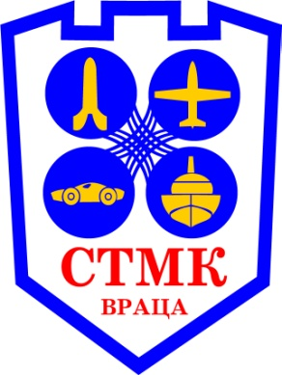
GP Large Scale Off Road Bulgaria
08 July to 10 July 2016, ledenika –Vratza
(Also open Bulgarian championship 1/8 IC Off-road and Electro Off-road)

Sponsor: BFAMS, STMK –Vratsa
Main organizer – Damyan Petrov;
e-mail: bfamsfed@abv.bg

Track Location: Ledenika - Vrata /near to the cave Ledenika/
(Copy link below)
https://www.google.bg/maps/place/43%C2%B012'16.2%22N+23%C2%B029'22.4%22E/@43.204514,23.489542,18z/data=!3m1!4b1!4m2!3m1!1s0x0:0x0
Track is open for free practice on 07.07.2016 12:00h – 18:00h
Rules: EFRA-Rules for all OFF-ROAD Scales.
Nearest GAS station: GAS STATION - 16 km distance from the track- Ledenika
Free: Drivers area, electric power 230V, compressor, “WC” shower, refreshment, parking- aria and camping facilities are available also caravan parking.The organizers will meet and transport the participants in the race from Sofia Airport to Ledenika. /Sofia Airport is located 120 km from Ledenika/ For assistance with accommodation - write email: bfamsfed@abv.bg

The STMK Vratsa will enjoy meeting you at the track!

REGISTRATION FORM

YOUR DETAILS:

Driver Name: Last Name:…………………… First Name………………………………….

Country:………………………………………………

Transponder Number : ………..

Frequency of transmitter(DSM,27Mhz,40Mhz) : ……….

Class: ………………….
/per class – 30 euro/

E-mail: Send completed Doc. File entry form to : bfamsfed@abv.bg
Tax must pay at Registration on the Track
Entries Close: 30 th June

For Information regarding:
Hotels: http://www.hotel-kiparis.eu/; 6km. from the Track
http://www.hotel-ledenika.com/ 50m. from the Track
http://www.chaika.net 16km from the Track
http://momina-salza.eu/ 6km from the Track
http://www.hotelhemus.com/page.php?n=18043&SiteID=446 17km from the Track

